Lab 02 – **Task 01**

public class SimpleThread extends Thread{

public void run(){

System.out.println(Thread.currentThread().getId()+"is executing the thread.");

}

}

public static void main(String[] args) {

SimpleThread thread1 = new SimpleThread();

SimpleThread thread2 = new SimpleThread();

thread1.start(); // Starts thread1

thread2.start(); // Starts thread2

}

}

Output

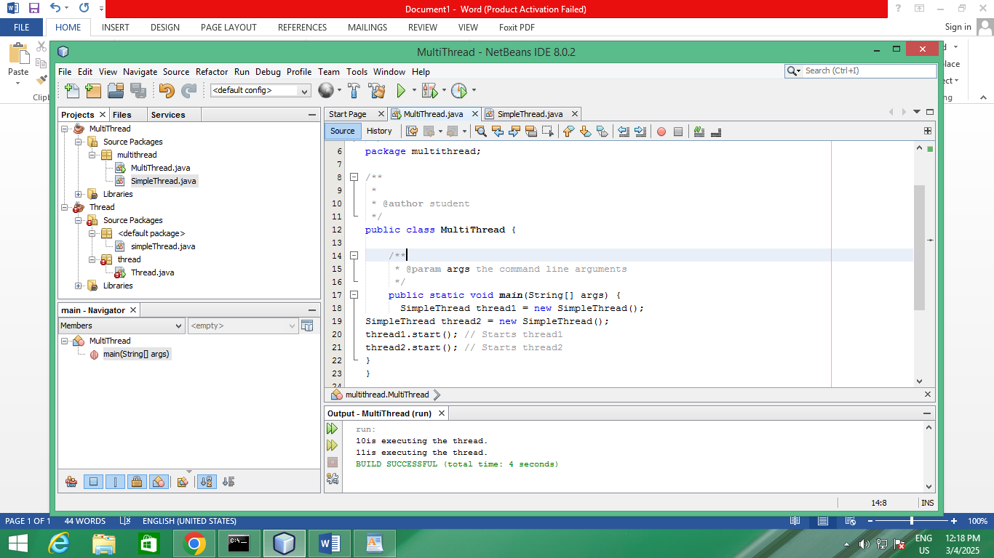

**Task 02**

public class RunnableTask implements Runnable{

@Override

public void run() {

System.out.println(Thread.currentThread().getId()+ "is executing the runnable task.");

}

}

public static void main(String[] args) {

RunnableTask task1 = new RunnableTask();

RunnableTask task2 = new RunnableTask();

Thread thread1 = new Thread(task1);

Thread thread2 = new Thread(task2);

thread1.start(); // Starts thread1

thread2.start(); // Starts thread2

}

}

Output

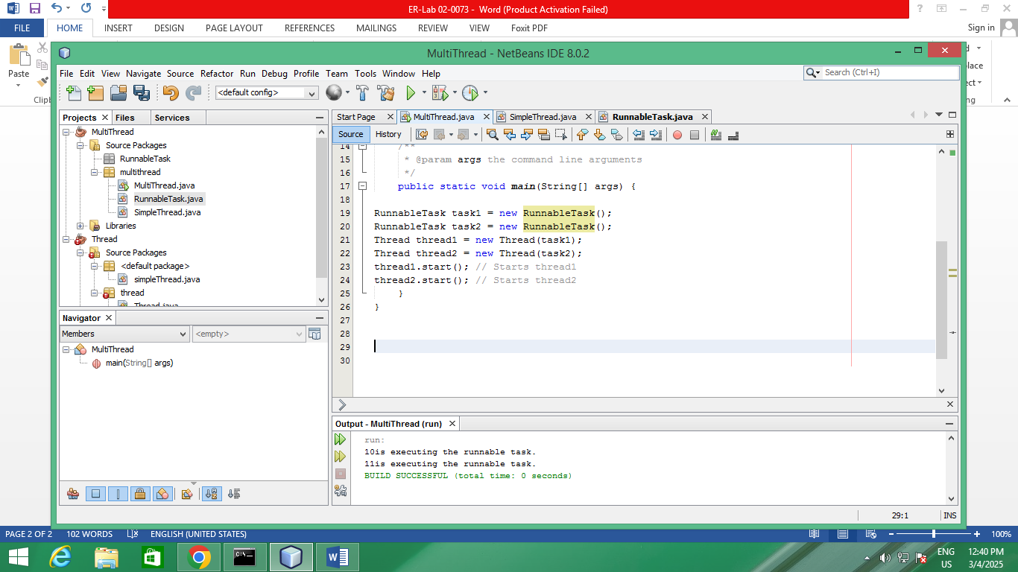

**Task 03**

public class Counter {

private int count = 0;

// Synchronized method to ensure thread-safe access to the counter

public synchronized void increment() {

count++;

}

public int getCount() {

return count;

}

}

public class SynchronizedExample extends Thread {

private Counter counter;

public SynchronizedExample(Counter counter) {

this.counter = counter;

}

@Override

public void run() {

for (int i = 0; i < 1000; i++) {

counter.increment();

}

}

**}**

public static void main(String[] args) throws InterruptedException {

Counter counter=new Counter();

// Create and start multiple threads

Thread thread1 = new SynchronizedExample(counter);

Thread thread2 = new SynchronizedExample(counter);

thread1.start();

thread2.start();

// Wait for threads to finish

thread1.join();

thread2.join();

System.out.println("Final counter value: " + counter.getCount()**);**

**}**

**}**

Output

